Seven Bridges Field Club Swim Coach Position Description:
2018 Summer Swim Season:
Pre-Season: June 18thth to 22th 5pm to 6pm
Season: June 25h to July 27th 10:00am – 1:00pm
Season: Meets per Division 5 schedule (T,TH, some Sat) Championship and All Stars: July 28/29 with sleepover

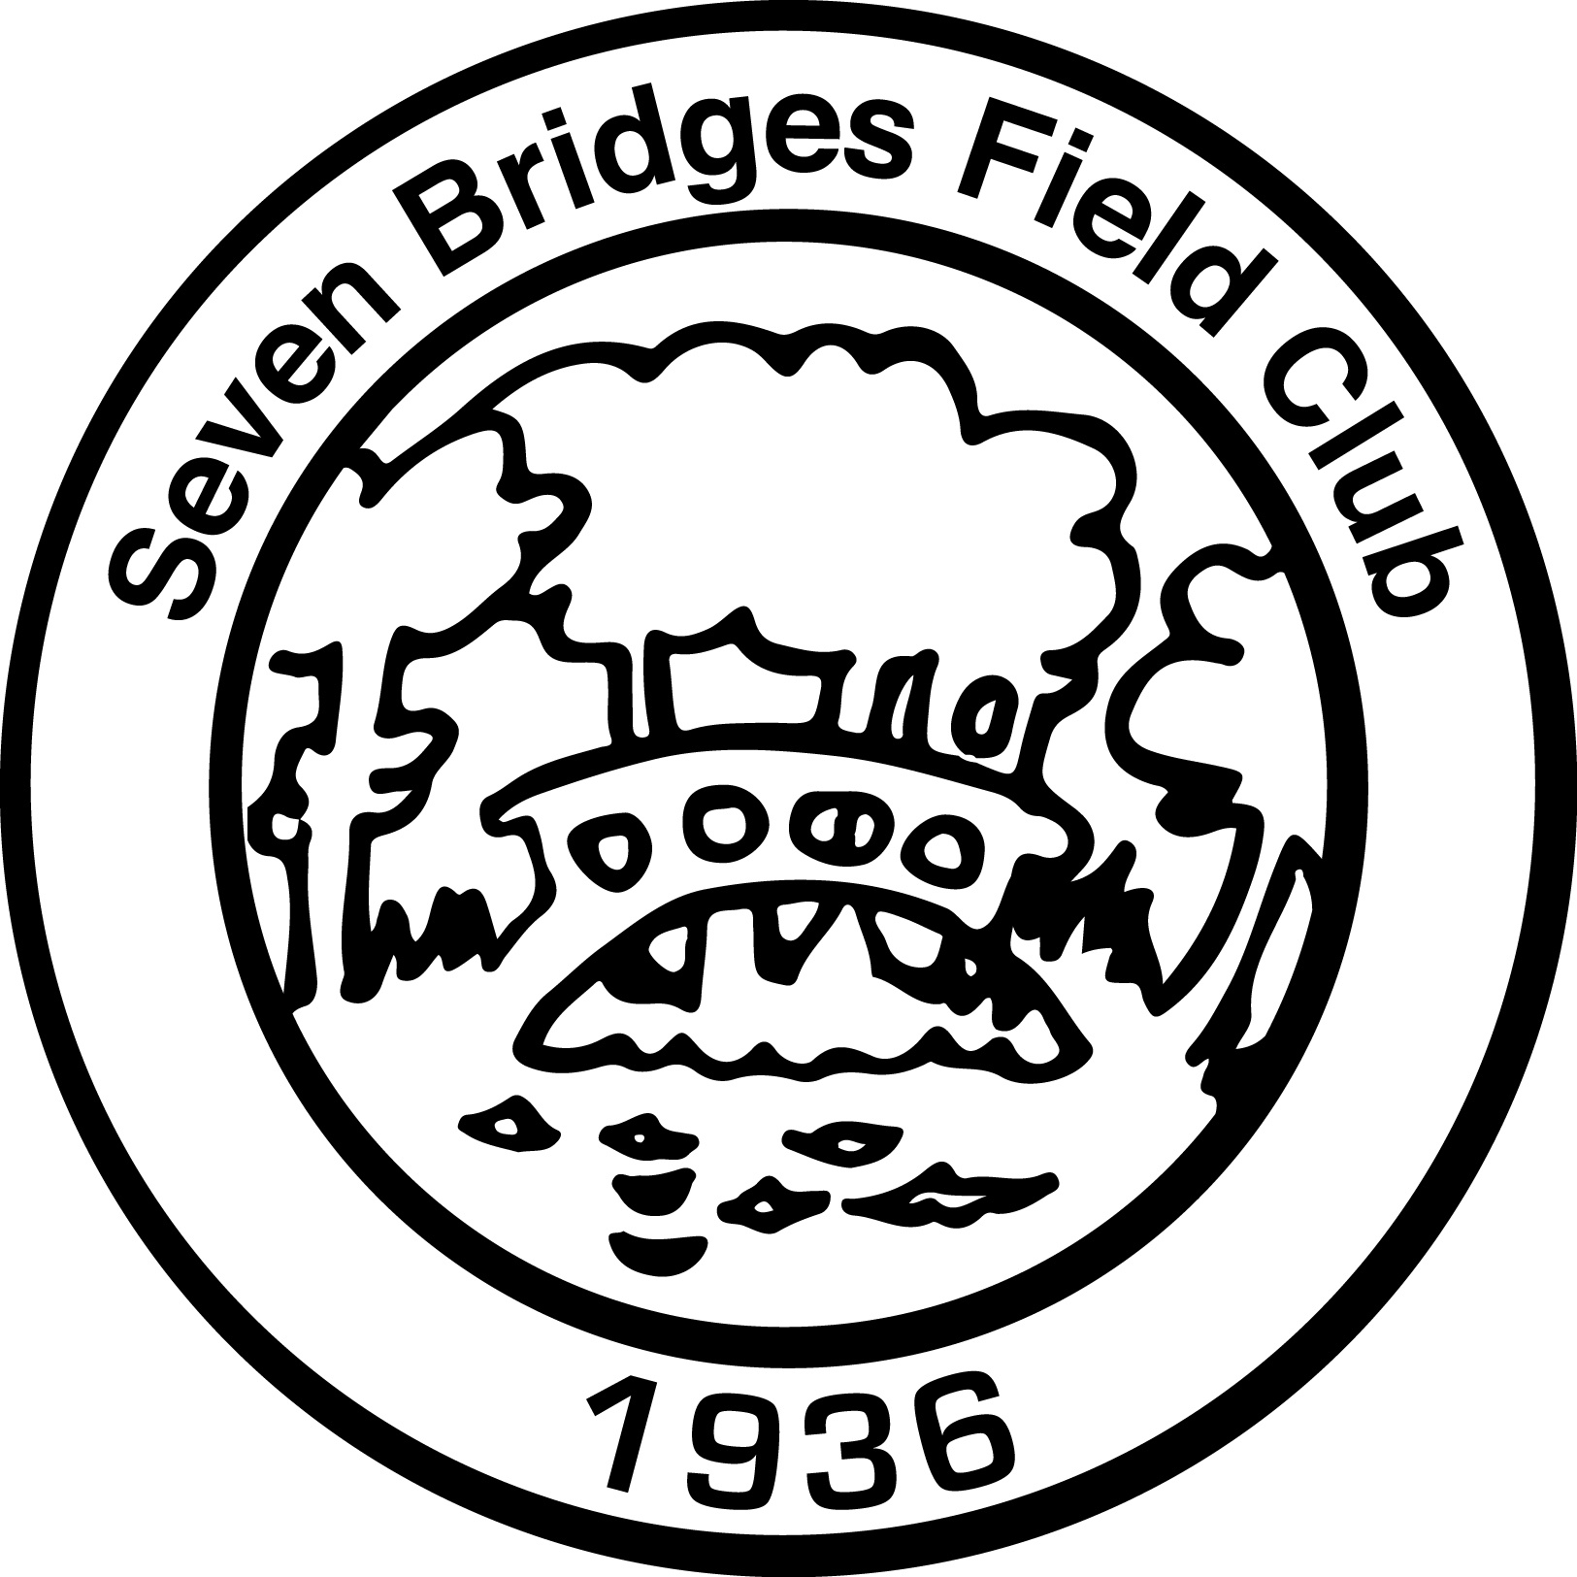
General Description: Candidate is responsible for administering the swim team program for the Seven Bridges Field Club. Trains and guides swim team on the correct swimming strokes and techniques. Plans and organizes practice sessions and swim meets in accordance with the Northern Westchester Swim Conference requirements. Works to maintain fun, nurturing and competitive culture at the club.

Minimum Qualifications:
- Must possess current lifeguard training and CPR certificates
- Experience on a competitive swim team and water training instructor certification are desirable
- Ability to build positive relationships with team members
- Ability to manage oneself and team in an emergency situation
- Ability to demonstrate excellent communication and follow up skills
Functions to Perform:
- Attend a couple NWSC meetings as needed
- Work with assistant or co-coach to achieve desired results
- Teach all competitive strokes, rules and regulations to team members
- Understand individual weakness and train them accordingly
- Plan and organize the following: o Practice plan and swim meet paperwork o Fun Friday themes and color wars week in conjunction with team o Plan end of season day trip for older swim group o End of season awards banquet, awards and club sleepover
* Interested candidates, please email Amanda Greene @ mandybg@optonline.net
* Please apply by Friday, February 23rd to be considered
* Interviews via phone or live will take place by mid March

